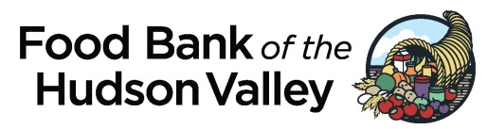

The 4th Annual Farm-to-Fork Feast
November 2018
Location: TBD

Event Committee Member Responsibilities

The Farm-to-Fork Feast is the primary fundraising event for the Food Bank. This year, our goal will be to raise $100,000 (gross). Committee members can help in any one (or more) of the following ways:

- Help plan and coordinate the event
- Identify and solicit corporate sponsors
- Identify and solicit honorary committee members
- Acquire items for the live auction, silent auction, and raffle
- Recruit regional food and beverage businesses (restaurants, caterers, brewpubs, wineries, etc.) to provide hors d’oeuvres during the cocktail hour
- Recruit other volunteers for the Event Committee
- Help promote the event and sell tickets
- Seek in-kind/pro bono goods and services
- Help support the Food Bank and its mission
- Have fun!

The Committee will meet several times throughout the year beginning in April. Members have the option of attending one-hour committee meetings in person (at the Food Bank) or by phone.

To be part of this lively group, or to find out more, please contact Paul A. Stermer at:
- (845) 534-5344 ext. 104
- pstermer@foodbankofhudsonvalley.org

The 17th Annual Walk to Fight Hunger
October 7, 2018
Location: Walkway Over the Hudson (Highland, NY)

Event Committee Member Responsibilities

The Walk to Fight Hunger helps raise awareness of hunger relief and funds for the Food Bank. This year, our goal will be to raise $20,000 (gross) through corporate and individual sponsorships. Committee members can help in any one (or more) of the following ways:

- Help plan and coordinate the event
- Help create method to register participants and collect sponsorships
- Identify and solicit corporate sponsors
- Recruit other volunteers for the Event Committee
- Help promote the event
- Help support the Food Bank and its mission
- Have fun!

The Committee will meet several times throughout the year beginning in April. Members have the option of attending one-hour committee meetings in person (at the Food Bank) or by phone.

To be part of this lively group, or to find out more, please contact Paul A. Stermer at:
- (845) 534-5344 ext. 104
- pstermer@foodbankofhudsonvalley.org

