Feeding with Thought
Member Agency Newsletter
April 2021
Special Electronic Edition

Agency Updates
Executive Director, Mark Quandt, to Retire in Fall 2021
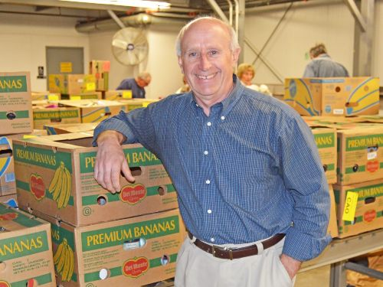
After a remarkable 38-year career at the Regional Food Bank of Northeastern New York, Executive Director Mark Quandt is retiring.
Mark began his career in 1983 as a Warehouse Manager when the Food Bank was serving just 60 agencies in 8 counties distributing approximately 400,000 pounds of food. Quandt was promoted to Executive Director in 1984 and today, through his leadership, the Regional Food Bank serves nearly 1,000 agencies in 23 counties distributing over 55 million pounds of product annually.
Under Mark’s leadership, many innovative programs were developed to expand the reach of the Food Bank to underserved communities with specific emphasis on providing services to children and seniors. He used creative approaches to connect available food sources to the Food Bank communities including operating a farm to provide fresh produce, building relationships with food manufacturers and wholesalers, and organizing hundreds of retail grocery stores to donate food that would otherwise go to waste. He has worked tirelessly to broaden partnerships, increase awareness and continually communicate the need to alleviate hunger in our communities, especially during the COVID-19 pandemic.
Mark not only succeeded in serving individual and community needs, but he has been instrumental in developing the complex infrastructure and sophisticated management required to operate the large food bank. He has built a highly-trained and professional team of staff and volunteers that carry out their duties with tremendous skill and an overwhelming caring attitude.
When asked about his thoughts on retiring from the Food Bank Mark Quandt said, “It has been an honor to work alongside professionals such as the board, staff, volunteers, agencies, donors and community leaders in the 23-county region, who are all truly dedicated to our mission of alleviating hunger and reducing food waste. I will always look back with affection and pride on what the Regional Food Bank has accomplished. It has been a wonderful journey. The Food Bank will always have a place in my heart and I will continue to support the organization in any way I can. Meanwhile, I will leave it in the very capable hands of the leadership team with confidence the great work will continue.”
A search committee has been formed to hire a new leader for the organization. Quandt will continue in his current role until his successor is identified and transitioned.
from www.regionalfoodbank.net

Upcoming Workshops
All trainings will remain virtual for the time being! If you have any ideas for virtual agency trainings, please contact anyone in our Member Services Department. We'd love to hear from you!
Upcoming workshops are listed below. Postcards will be sent in the mail the month before. Registration is done through the Agency Education section of our website.
- Nutrition Workshop: Meal Planning Reimagined
- Regional Food Bank and Online Ordering Orientation (two dates available)
- Food Safety (two dates available)
Click to access webinar registration

We want your feedback!
Our Agency Services team has been working hard to transition all trainings onto new digital software. It is important to us that we maintain the quality of the information we are sharing! We value the feedback of our member agencies and for that reason we ask that you consider filling out our brief survey. This survey will ask 8 questions on your experience with webinar trainings. Please help us continue to develop our online training skills!
Webinar Training Feedback Survey

Staff Changes at Food Bank of the Hudson Valley
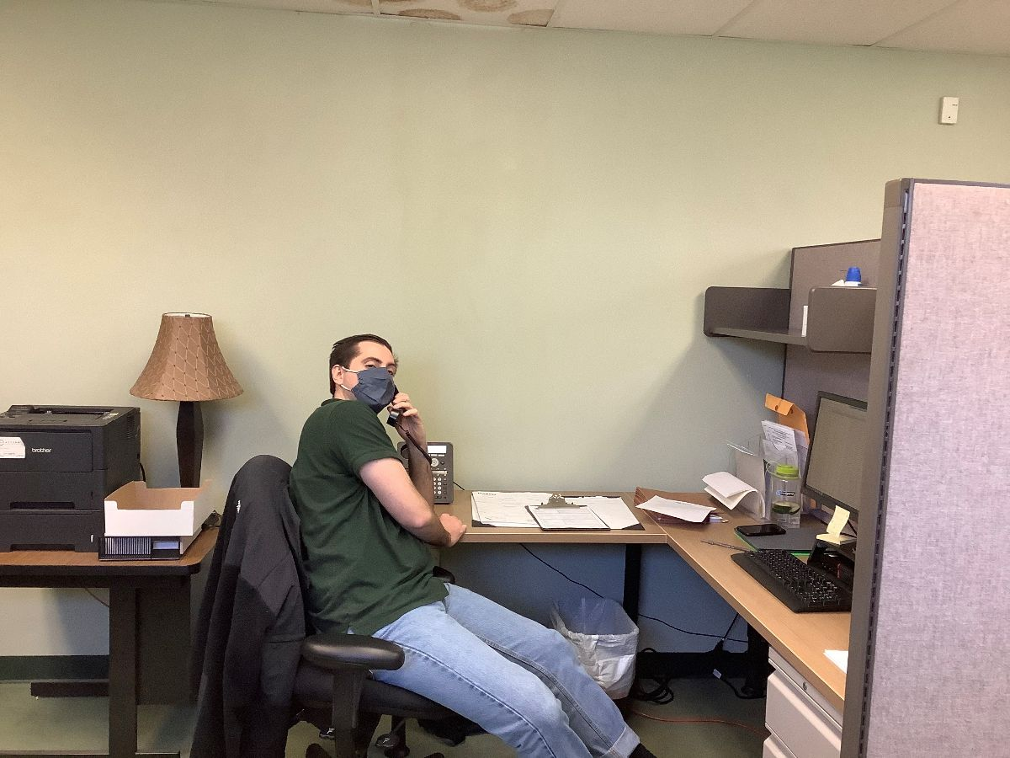

We are thrilled to announce that Michael Barbera has accepted the Agency Services Coordinator position for the Food Bank of the Hudson Valley! Michael is a graduate of SUNY New Paltz and brings a passion for helping others and an interest in food insecurity. He will work alongside Food Bank member agencies to conduct monitor visits, ensure compliance, and provide guidance and support. Michael has been training with his predecessor, former Agency Services Coordinator, Amy Robillard. Amy has worked alongside Michael to ensure a smooth transition while learning the ropes of her new position as Direct Delivery Coordinator with the Community Impact Department. Please join us in welcoming Michael and congratulating Amy in their new positions!

Attention HPNAP/OS Grant Recipients!!
As a reminder, you must spend the remainder of your HPNAP food grant funds on orders picked up on or before
June 25, 2021
Operations Support (OS) documentation for this current grant period is due no later than
May 31, 2021

Agency Spotlight: Prabhuji Mission Food Pantry

In this issue of Feeding with Thought, we would like to recognize Prabhuji Mission Food Pantry in Greene County. Prabhuji has adopted a drive thru method for their clients, and they want to keep it!
Grounded in the idea of reducing food waste, Prabhuji Mission Food Pantry's Director of Operations, Govinda, has dubbed himself and his co-volunteers "Professional Food Rescuers." This team began rescuing food in New York City, and would then drive it to any agency that would accept the product for distribution to their clients. While in New York City, Govinda and his God-Brothers and Sisters had an "on-call" phone with them throughout the night, so they would be ready to rescue food that a store could not hold. These massive amounts of food were also brought to agencies near the team's Ashram in Round Top, NY to continue to eliminate waste and as well as feed their community members. Now solely in Round Top, the Prabhuji Mission Food Pantry is running what they have dubbed their "Good Neighbor Program" where they collaborate with a network of their fellow community members and other pantries to make sure that those who are not able to pick up food at the Pantry are fed and food is saved.
This focus on "rescuing food" has allowed visitors to the Prabhuji Mission Food Pantry to be the ones who are making the contribution rather than the taking. Taking food as nourishment rather than it being disposed of, (especially when there's fresh produce!) is the ultimate goal of the Prabhuji Mission Food Pantry. Clients are reminded of this during their visit. They are reminded that they are the one(s) who is (are) doing the "giving." Fostering an environment of "love, respect and trust." Prabhuji has created a distribution method that will continue to work to make clients feel welcomed and an important part of the community. Communal spaces on the property are available to clients during nice weather and non-pandemic times, named "Pantry in the Park" where community members can gather on the Ashram property after collecting food.
What started as an effort to reduce food waste has grown into a community driven to get wholesome, fresh foods to families and individuals. A sustainable partnership with an exchange of "love, respect, trust" and of course, food!
We are thrilled to recognize Prabhuji Mission Food Pantry and the work they do!
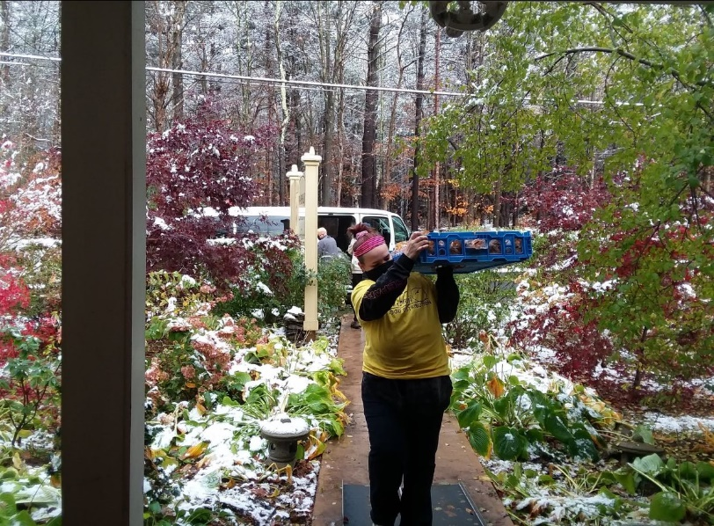
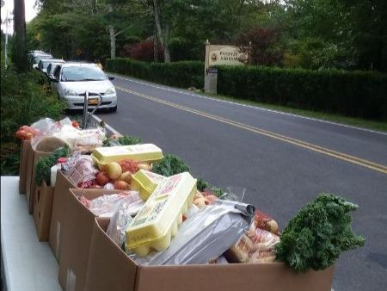
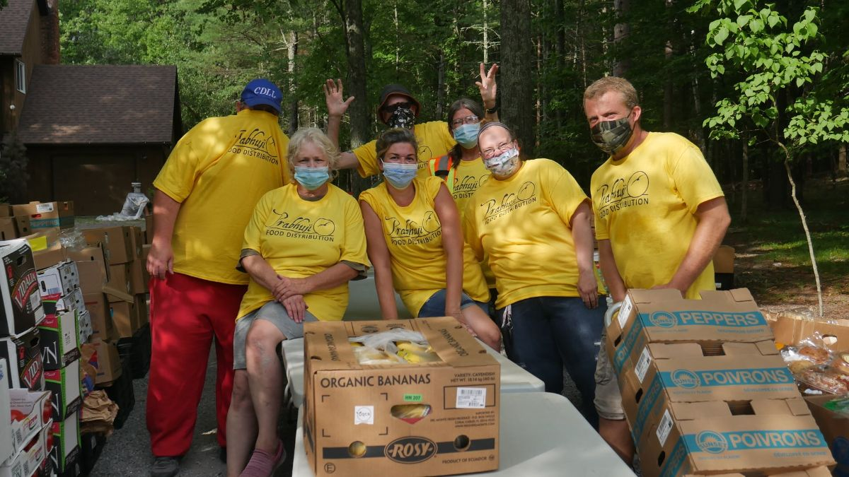

Update on Nourish New York Initiative (NNY)
"We’re thrilled to hear Nourish NY will now be an official program in the NYS Budget!"
--Joanne Dwyer, Director of Food Industry Relations and Business Development at Regional Food Bank of NENY

This program will be added to the NYS Budget for this upcoming year to continue the partnership between NYS, local Farmers and Food Banks! Click here to read a press release about NNY being added to the New York State Budget from NYS Senator, George Borrello.
At the Regional Food Bank, our agencies have made great use of this free product! The poundage report for the amount of NNY product ordered by county between the period 5/1/2020 to 2/28/2021 is listed below for our agencies to see.
NNY Poundage Report: Find your county! Click Here

Agency Advisory Council - April Meeting Minutes
Click below to view the minutes from our April Agency Advisory Meeting! We discussed operating during COVID-19, changes at the Regional Food Bank and more!
April Advisory Minutes

General Resources
Friendly Reminder: Masks are required when you visit the Regional Food Bank, Food Bank of the Hudson Valley and at delivery sites!
Please help us ensure that operations continue as best as they can to serve those in need throughout Northeast New York State. If you have questions please contact Member Services.
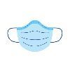

Latest Updates Regarding COVID-19
COVID-19 Vaccine and General Information
For the most current information on COVID-19 protocols and the COVID-19 vaccine we ask that you refer to the New York state website. This resource will offer the most up to date information that can be provided. We will share updates when we receive them ourselves.
Click to access Updates on COVID-19 Virus
Click to access Updates on COVID-19 Vaccine

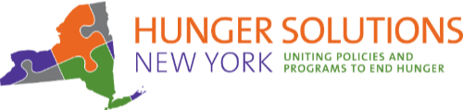

COVID-19 Emergency Allotments to ALL SNAP Recipients in April
Emergency Allotments (EA) of SNAP benefits were authorized by Congress under the Families First Coronavirus Response Act of 2020. The EA of SNAP will continue each month until the COVID-19 public health emergency is lifted in our state or nation.
Starting in April 2021 all SNAP households are now eligible for the EA supplement benefit. In April 2021 EA of SNAP benefits will now be:
- $95 a month for those already receiving the maximum SNAP benefit,
- $95 a month for those with a calculated EA amount of less than $95, and
- for all other households the EA amount will equal the difference between their regular monthly SNAP benefit and the maximum benefit for their households’ size.
For more detailed information please see the April 13 update to the SNAP section of our COVID-19 page.
Click for access Updates on changes to government assistance

Nutrition Education
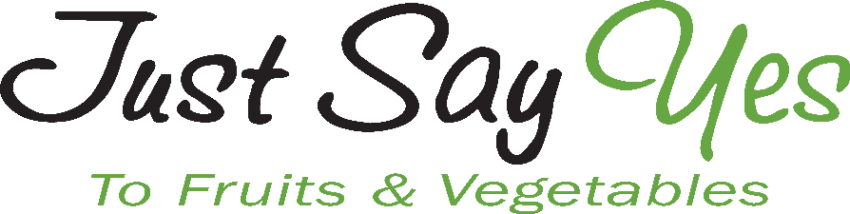

Food Bank Farm Stand Program:
Bringing Produce to Families with Preschool Aged Children

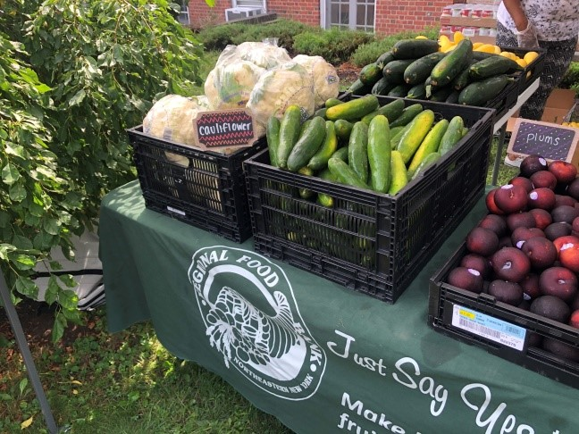

Studies show that offering a variety of fruits and vegetables and allowing children to help choose produce increases the likelihood that they will eat and like the foods. The Community Impact Department, in partnership with Just Say Yes to Fruits and Vegetables, is launching a new program called the Food Bank Farm Stand program. The goal of the Food Bank Farm Stand is to provide fresh fruits, vegetables, and other nutritious foods to families at low income childcare centers. Our plan is to set up a farm stand so that produce is available for parents to “shop” when they come to pick up their children. The JSY Nutritionist would also provide nutrition education, recipes, and cooking tips for the items that they receive to help families learn more about the different ways they can utilize their produce. This program is free to both childcare centers and families.
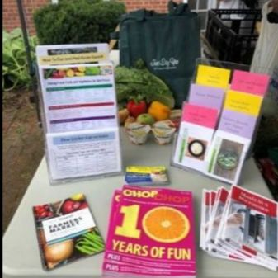
If you are or know of a childcare center
that would benefit from the Food Bank
Farm Stand program please contact one of
our JSY Nutrition Educators:

Kristyn Bopp: (518)-786-3691 x225
KristynB@regionalfoodbank.net
Monica Cieslak-Morgan: 845-534-5344 x109
MMorgan@foodbankofhudsonvalley.org

JUST IN TIME DELIVERY PROGRAM
Due to feedback from our members that the amount of fresh, perishable product that can be provided to clients is oftentimes limited due to onsite storage or transportation capacity, we have developed our “Just in Time Delivery Program.”
This program aims to overcome these obstacles by providing delivery of fresh, nutritious foods such as produce, dairy, and other items immediately before you open so that you may expand your ability to provide these high quality foods directly to the clients you serve!
Just in Time FAQ
Q: Is there a fee to participate?
A: No, delivery and drop off is free.
Q: How often may I receive a Just in Time Delivery?
A: As of now, we are thinking once per week. However, you may opt to receive deliveries once or twice a month as well. We’ll work with you as we are still piloting this program.
Q: What if I don’t have refrigeration capacity?
A: This program is designed to overcome this operational obstacle by providing delivery immediately before opening. If you need freezer blankets, we can purchase them for you.
If this sounds like a fit for your agency, or you would like a little more information please follow the link below to complete the survey. Please know that we are in the development stages of this program and are not planning on fully starting until September when our new truck is available. It may take some time for you to hear from us, but we will be in touch! Just in Time Interest Survey
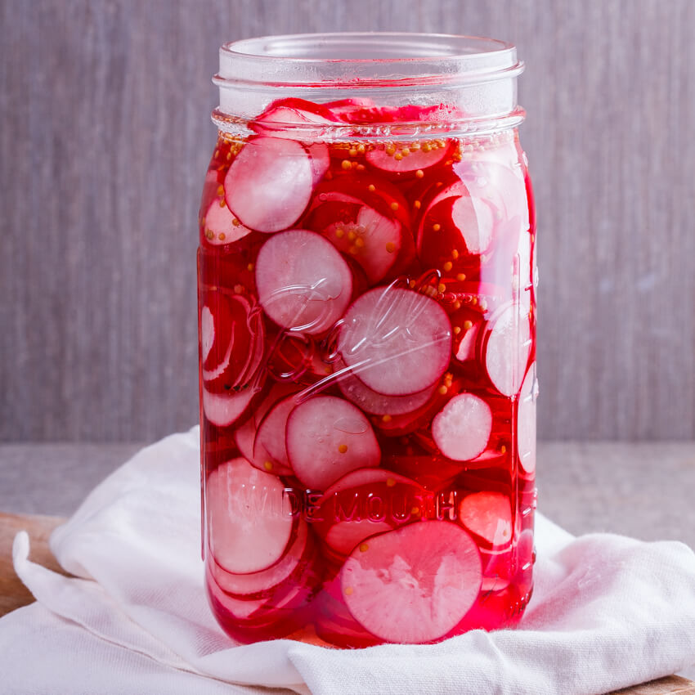

Pickled
Radishes

Ingredients:
2 cups sliced radishes
1/2 teaspoon salt
1 teaspoon honey or sugar
1 cup vinegar
Directions:
1. Sprinkle sliced radishes with salt. Set aside.
2. Make dressing: in a small bowl, combine honey and vinegar and mix well.
3. Pour dressing over radishes.
4. Cover and set aside at room temperature for 20-30 minutes.
5. Drain liquid before serving.
6. Enjoy or refrigerate and serve cold!
7. Refrigerate leftovers.
https://jsyfruitveggies.org/pickled-radishes/

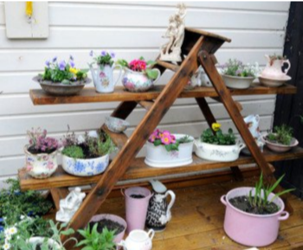
Ready, Set, GROW! Beginner's Guide to container gardening
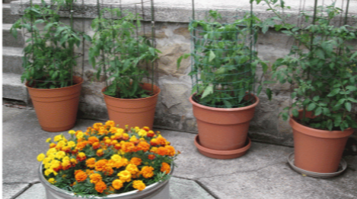
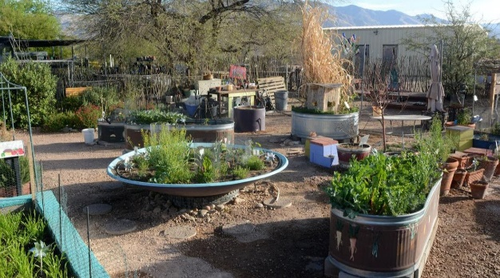
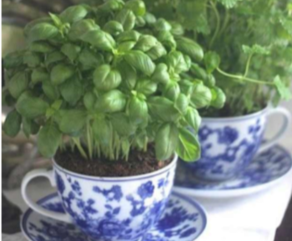
Choosing Containers:
· Dark colored pots retain heat and don’t work as well
· Terra Cotta (clay) pots are porous and lose moisture quickly
· If using wood:
· Choose untreated wood so that chemicals don’t leach into the soil
· Avoid containers that contained chemicals
If choosing plastics:
·Avoid clear plastic so the roots don’t burn
· Look at the recycle triangle symbol
· Use numbers 1, 2, 4, 5
· Avoid numbers 3, 6, 7
Preparing Containers For Use:
· Scrub with dish soap, rinse with plain water, dry
· Rinse with a bleach solution of 1 part bleach to 9 parts water, dry
· Add drainage holes at bottom of container
· Add material to aid in drainage, such as Styrofoam peanuts or shredded paper if desired
· Use enriched potting soil, not garden soil
Choosing Plants:
· Choose a plant appropriate to the size container being used
· If planting a larger plant, choose a bush or dwarf variety for best results
· SNAP benefits can be used to purchase fruit/vegetable seeds or plants
· Wet the soil first
· Plant the seed or plant
· If a tomato plant, add stake or cage now
· Water thoroughly
Location:
· Choose a spot with at least 6 hours of sunlight
· If possible, choose an area that is protected from the wind
· For larger plants and containers, be sure to plant in the desired location
· Water often enough that the soil remains damp, not wet. The smaller the container, the more often it will need to be watered

Check out this video to learn how to container garden on a budget!
Click here

Delivery Information
Regional Food Bank Delivery Sites for 2021
Food Bank Delivery Dates for 2021
Click here for the current Drive-Thru Pantry Schedule

Ordering Information
To Order from Our Latham Facility or a Delivery:
Appointments for Latham pick-ups are on Mondays, Tuesday Mornings, Thursdays, and Fridays.
Go to www.regionalfoodbank.net where our inventory is updated on Mondays, Tuesdays and Fridays.
Order weekdays from 9am-2pm, 2-5 business days before your pick-up date as follows:
· By phone at 518-786-3691
· By fax at 518-786-3004
· By Email at fborders@regionalfoodbank.net
· Using our Online Ordering system (you must receive training)
To Order from Our Cornwall-On-Hudson Facility:
Appointments for Cornwall-on-Hudson pick-ups are on Mondays, Wednesdays, and Fridays.
Go to www.foodbankofhudsonvalley.org; our inventory is updated on Mondays, Tuesdays and Fridays.
Order weekdays from 9am-2pm, 2-5 business days before your pick-up date as follows:
· By phone at 845-534-5344
· By Email at orders@foodbankofhudsonvalley.org
· By fax at 845-534-5256
· Using our Online Ordering system (you must receive training)

